Commission Amendment Update for 2026
Update from Amendment on August 20, 2025
Effective Date: January 1, 2025
Implementation Date: November 1, 2025
Impacted Counties: Marion and Polk
This Commission Schedule Amendment (“Amendment”) modifies and supersedes any prior agreements between ATRIO Health Plans (“Plan”) and the contracted Agent or Agency (“Producer”) regarding commission payments, and is incorporated into the Producer’s current Agreement.
1. Commission Update – Marion & Polk Counties (Effective November 1, 2025)
Beginning November 1, 2025, new business written in Marion and Polk Counties will be non-commissionable.
This applies to all new enrollments with effective dates of January 1, 2026, and beyond.
- New Business: No initial enrollment commission ($0) will be paid for MAPD or MA-Only plans written in Marion and Polk Counties effective 11/1/2025.
- Renewals: Renewal commissions at both the Agent and Agency level will remain unchanged.
- Impacted Plans:
  - ATRIO Prime Rx (H7006-007)
  - ATRIO Basic Rx (H7006-022)
  - ATRIO Select Rx (H7006-004)
Note: Applications submitted through October 31, 2025, with effective dates of January 1, 2026, will continue to be eligible for commissions under the prior schedule.

2. Initial Enrollment Commissions – Agent Level (Effective January 1, 2026)
Applicable Counties: Douglas, Lane, Jackson, Josephine, Multnomah, Clackamas, and Yamhill
(MAPD, MA-Only, D-SNP, C-SNP)
- Paid at the CMS maximum “New to Medicare” rate of $694, calculated on a pro-rated basis.
- For enrollments with effective dates after January 1, 2026, commissions will be pro-rated monthly, with payment decreasing incrementally for each month following January.
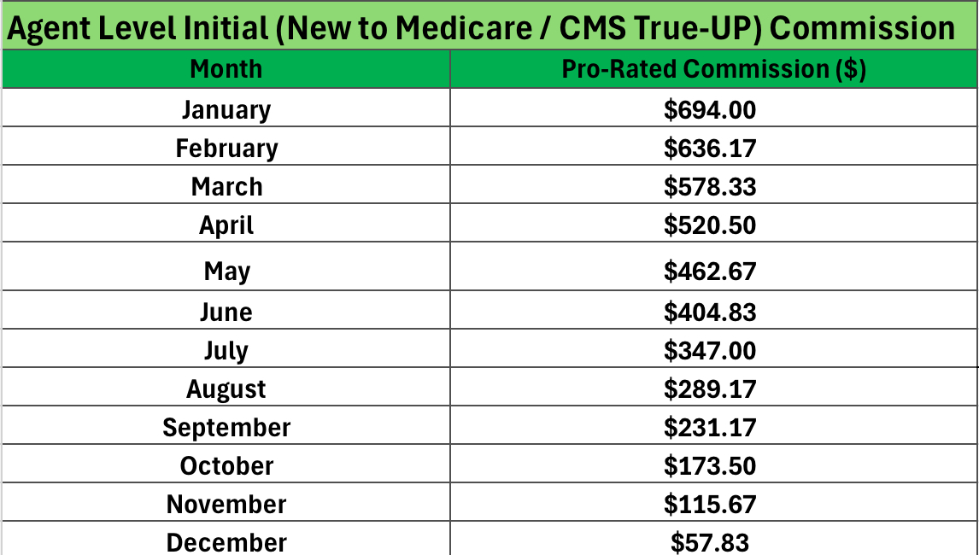
Pro-Rated Commission Schedule based on month of enrollment – Agent Level:

Klamath County (MAPD and MA-Only Plans) – Agent Level:
- No initial enrollment commission ($0) will be paid for any MAPD or MA-Only plan effective on or after January 1, 2026.
- D-SNP paid at the CMS maximum “New to Medicare” rate of $694, calculated on a pro-rated basis.
Marion and Polk Counties (MAPD and MA-Only Plans) – Agent Level:
Effective 11/1/2025
- No initial enrollment commission ($0) will be paid for any MAPD or MA-Only plan effective on or after January 1, 2026.
- Applications submitted through October 31, 2025, with January 1, 2026 effective dates, will continue to be paid under the standard 2026 pro-rated schedule.

2. Renewal Commissions – Agent Level:
Effective January 1, 2026, renewal commissions for Agent-level contracts shall be as follows:
Clackamas, Douglas, Lane, Marion, Multnomah, Polk, and Yamhill Counties:
- Renewal commission: $313 per member, per year.
Klamath County:
- Renewal commission: $150 per member, per year, applicable to both new and existing business.
Jackson and Josephine Counties:
- Renewal commission: $250 per member, per year, applicable to both new and existing business.

3. Overrides & Renewals – Special Conditions – Agency Level Contracts
Effective January 1, 2026, overrides &renewal commissions for upline contracts shall be as follows:
- No renewal commissions or overrides will be paid in Klamath, Jackson, or Josephine Counties at any upline level other than Agent-level renewals noted above.

- Overrides and renewal amounts in Douglas, Lane, Marion, Polk, Washington, Clackamas, and Multnomah Counties will vary by county and upline level as outlined in the applicable Override Schedule provided separately by county, please refer to agency-level contracts.
(Available September 2025, in EvolveNXT as part of the Annual Recertification process.)

4. General Terms
All commission payments are subject to applicable CMS regulations, state laws, and the terms of the Producer’s Agreement. The Plan reserves the right to amend commission schedules to maintain compliance with CMS or other regulatory requirements.

Acknowledgement:
By continuing to solicit enrollments for ATRIO Health Plans after January 1, 2026, the Producer acknowledges and accepts this Amendment as part of the contractual agreement with the plan.

